35. Develop a system using UML for Land Registration System. The system should maintain the database of the land detail and the owner of those lands. The system also maintains the citizen’s details having the lands in their name. Whenever the land is registered, the land owner's detail should be updated the same as the citizen's detail too. The amount transacted for the registration and the tax paid for it is also to be updated.

**SEQUENCE:**

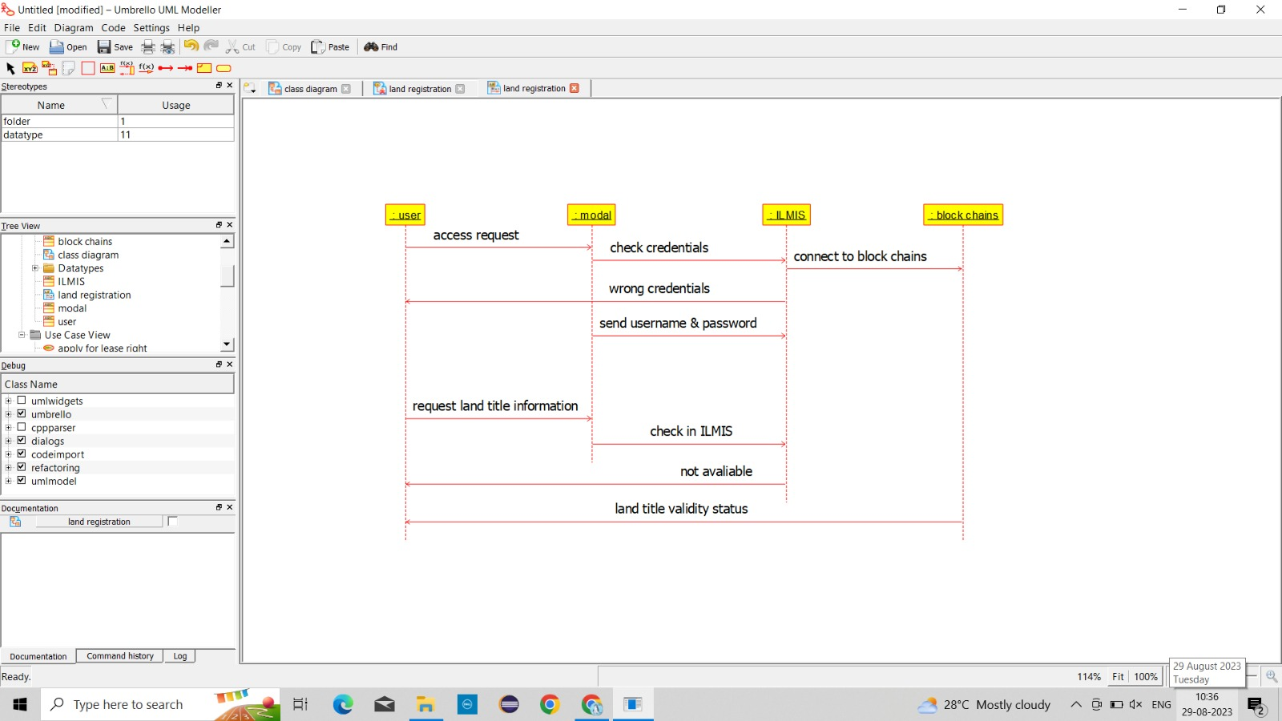

**USE CASE:**

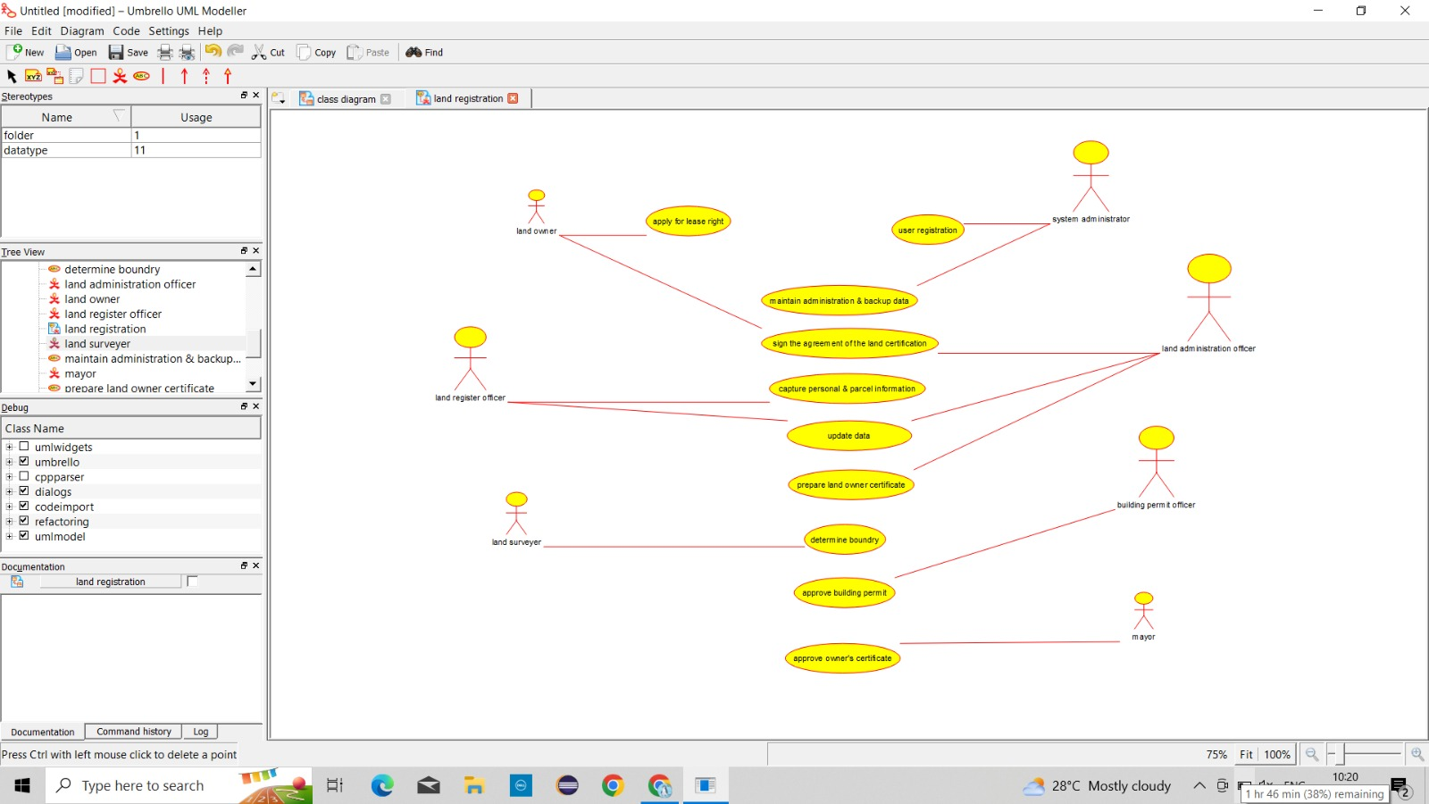

**ACTIVITY:**

